



Mock LLM API Responses and Test an AI-Powered Application
LAB MANUAL

Disclaimer: The content is curated from online/offline resources and used for educational purpose only
Mock LLM API Responses and Test an AI-Powered Application
Objective:
- Isolate AI application code from live, third-party Large Language Model (LLM) APIs using Python's standard mocking libraries.
- Simulate deterministic positive completions, malformed outputs, and critical failure modes (rate limits, timeouts, connection drops) using unittest.mock.
- Construct an automated PyTest suite to validate that error-handling routines, custom exceptions, and safety fallbacks trigger as designed without incurring cloud inference fees.
Problem statement:
Modern AI applications interface directly with external model inference providers over HTTP. Testing these applications against live endpoints introduces non-deterministic outputs, heavy network latency, cost spikes from token billing, and unpredictable rate-limit throttling (HTTP 429). These issues make continuous automated testing slow, expensive, and fragile.
You are required to develop an AI-powered text summarization and classification service that calls an external LLM endpoint. You will build an automated test suite that mocks out all underlying HTTP network calls, intercepts outgoing requests, returns controllable payload structures, and asserts that retry logic, custom exceptions, and fallback handlers execute deterministically in milliseconds without touching a live server.
Materials/ Equipment needed:
- Computer running Linux, macOS, or Windows.
- Python 3.10 or higher.
- Terminal / Command Line Interface.
- Python packages: pytest, requests.
- Code editor.
Prerequirties knowldege:
- Understanding of RESTful API request/response structures and standard HTTP status codes (200 OK, 429 Too Many Requests, 500 Internal Server Error).
- Familiarity with Python exception hierarchies (try...except, custom exception classes).
- Basic understanding of unit testing principles and PyTest assertions.

Theory:
Mocking is a testing pattern where external dependencies (such as external databases or third-party web APIs) are substituted with synthetic objects that mimic their interface and behavior during test execution.
In LLM engineering, mocking is essential for:
- Enforcing Determinism: Because generative language models are probabilistic, querying live endpoints can yield subtly different wording across runs, breaking strict assertions. Mocking produces exact, predictable payloads so you can test parsing and business logic reliably.
- Simulating Outages & Latency: Simulating an upstream provider outage (HTTP 500/503), quota exhaustion (HTTP 429), or a socket timeout in a live environment is difficult and inconsistent. A mock can trigger these exceptions on demand to verify application resilience.
- Eliminating Billing & Latency in CI: A standard test suite with dozens of prompt evaluations would consume substantial token quotas and take minutes to finish over a live network. Mocked objects run in memory, executing full test suites in fractions of a second at zero cost.
Python's unittest.mock.patch intercepts target function references (such as requests.post) during runtime, replacing them with a configurable MagicMock instance that logs call arguments and returns pre-set values or exceptions.
Procedure:
Step 1: Set Up Project Workspace and Install Dependencies Open your terminal, create a directory named mock_llm_app, initialize an isolated Python virtual environment, and install pytest and requests. Setting up an isolated environment keeps project dependencies contained, while installing pytest provides the test runner framework and requests acts as the standard HTTP client library communicating with external endpoints.
mkdir mock_llm_app
cd mock_llm_app
python3 -m venv venv
source venv/bin/activate
pip install pytest requests

Step 2: Establish Modular File Architecture
Create separate subdirectories for the application logic (src/) and automated test suites (tests/), along with package initializer files. Maintaining this separation ensures that application source code remains decoupled from test code, matching standard production repository structures and allowing PyTest to automatically discover test modules.

On Linux machine you can use thses commands to create the folder structure:
mkdir src tests
touch src/__init__.py tests/__init__.py
touch src/llm_service.py tests/test_llm_service.py
On Windows machine, you can manually create the below folder structure:
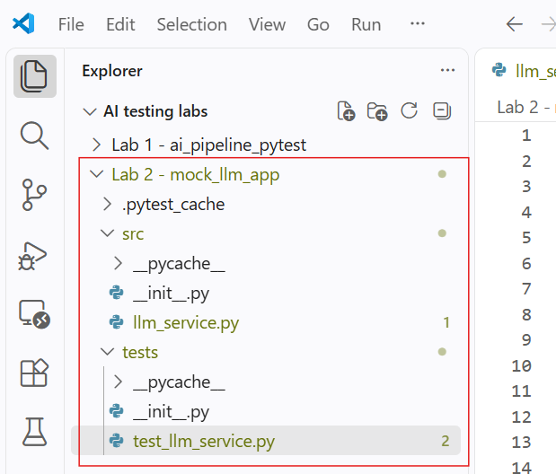
Step 3: Implement the LLM Client Application Module
Open src/llm_service.py and write the application logic, including custom domain exceptions (LLMRateLimitError, LLMServiceUnavailableError), the low-level API caller, and high-level classification logic with fallback mechanisms. Writing explicit exception handlers and fallback pathways ensures that the application degrades gracefully when external providers fail, preventing unhandled crashes in upstream user interfaces.
import requests
from typing import Dict, Any

class LLMBaseException(Exception):
"""Base exception for LLM communication failures."""
pass

class LLMRateLimitError(LLMBaseException):
"""Raised when the LLM provider returns an HTTP 429 status."""
pass

class LLMServiceUnavailableError(LLMBaseException):
"""Raised when the LLM provider experiences timeouts or 5xx outages."""
pass

class CustomerFeedbackClassifier:
def __init__(self, api_key: str, endpoint_url: str):
self.api_key = api_key
self.endpoint_url = endpoint_url

def _post_inference(self, prompt: str) -> Dict[str, Any]:
"""Send inference request to external API with explicit timeouts and error interception."""
headers = {
"Authorization": f"Bearer {self.api_key}",
"Content-Type": "application/json"
}
payload = {"prompt": prompt, "temperature": 0.0}

try:
response = requests.post(
self.endpoint_url,
headers=headers,
json=payload,
timeout=3.0
)
except requests.exceptions.Timeout:
raise LLMServiceUnavailableError("Inference request timed out after 3.0 seconds.")
except requests.exceptions.ConnectionError:
raise LLMServiceUnavailableError("Failed to establish connection to LLM API provider.")

if response.status_code == 429:
raise LLMRateLimitError("API quota or rate limit exceeded.")
elif response.status_code >= 500:
raise LLMServiceUnavailableError(f"Upstream provider error: HTTP {response.status_code}")
elif response.status_code != 200:
raise LLMBaseException(f"Unexpected API error: HTTP {response.status_code} - {response.text}")

return response.json()

def classify_urgency(self, feedback_text: str) -> str:
"""Classify user feedback into HIGH, MEDIUM, or LOW urgency with safe fallbacks."""
prompt = f"Classify the urgency of this support feedback as HIGH, MEDIUM, or LOW: {feedback_text}"

try:
data = self._post_inference(prompt)
# Parse target response string from completion payload
label = data.get("choices", [{}])[0].get("text", "").strip().upper()

if label not in ["HIGH", "MEDIUM", "LOW"]:
return "MANUAL_REVIEW"
return label

except LLMRateLimitError:
# Fallback when rate-limited: queue for delayed background batch processing
return "QUEUED_FOR_RETRY"

except LLMServiceUnavailableError:
# Fallback during provider outage: route directly to manual review triage
return "MANUAL_REVIEW"
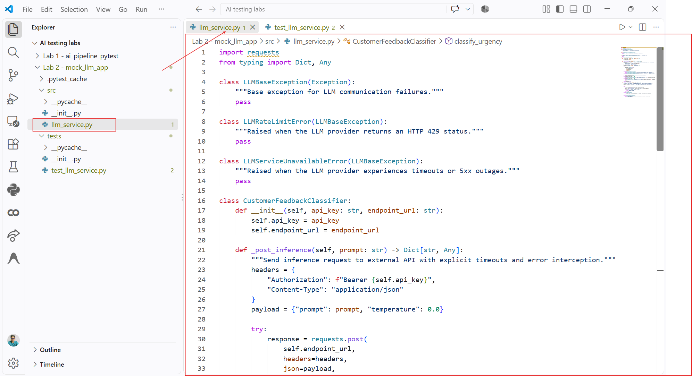

Step 4: Build Automated PyTest Suite Using unittest.mock.patch
Open tests/test_llm_service.py and write unit tests that use unittest.mock.patch to intercept requests.post calls, simulate varying status codes and network exceptions, and assert that the client processes responses and fallbacks correctly. Using patch and MagicMock lets you verify HTTP headers, validate payloads, and test every failure scenario locally without placing an actual network call or spending API credits.
import pytest
from unittest.mock import patch, MagicMock
import requests
from src.llm_service import (
CustomerFeedbackClassifier,
LLMRateLimitError,
LLMServiceUnavailableError,
LLMBaseException
)

@pytest.fixture
def classifier():
"""Provides a fresh classifier instance configured with mock credentials."""
return CustomerFeedbackClassifier(
api_key="mocked-test-api-token",
endpoint_url="https://api.mock-provider.internal/v1/completions"
)

@patch("src.llm_service.requests.post")
def test_successful_classification(mock_post, classifier):
"""Verify standard positive API response parses the urgency tag correctly."""
mock_resp = MagicMock()
mock_resp.status_code = 200
mock_resp.json.return_value = {
"choices": [{"text": "HIGH"}]
}
mock_post.return_value = mock_resp

result = classifier.classify_urgency("System is down and data is corrupt!")

assert result == "HIGH"
mock_post.assert_called_once()

# Assert header and payload structure
sent_headers = mock_post.call_args[1]["headers"]
sent_json = mock_post.call_args[1]["json"]
assert sent_headers["Authorization"] == "Bearer mocked-test-api-token"
assert "System is down and data is corrupt!" in sent_json["prompt"]

@patch("src.llm_service.requests.post")
def test_rate_limit_triggers_queued_fallback(mock_post, classifier):
"""Verify HTTP 429 returns the fallback QUEUED_FOR_RETRY status."""
mock_resp = MagicMock()
mock_resp.status_code = 429
mock_resp.text = "Too Many Requests"
mock_post.return_value = mock_resp

result = classifier.classify_urgency("App is loading slowly.")
assert result == "QUEUED_FOR_RETRY"

@patch("src.llm_service.requests.post")
def test_network_timeout_triggers_manual_review_fallback(mock_post, classifier):
"""Verify request timeouts trigger the MANUAL_REVIEW fallback."""
mock_post.side_effect = requests.exceptions.Timeout("Connection timed out")

result = classifier.classify_urgency("Cannot login to dashboard.")
assert result == "MANUAL_REVIEW"

@patch("src.llm_service.requests.post")
def test_server_500_error_triggers_manual_review_fallback(mock_post, classifier):
"""Verify upstream 500 server errors are caught and trigger fallback handling."""
mock_resp = MagicMock()
mock_resp.status_code = 500
mock_resp.text = "Internal Server Error"
mock_post.return_value = mock_resp

result = classifier.classify_urgency("Please help with billing.")
assert result == "MANUAL_REVIEW"

@patch("src.llm_service.requests.post")
def test_malformed_model_completion_handling(mock_post, classifier):
"""Verify unexpected responses (hallucinations or conversational filler) route to manual review."""
mock_resp = MagicMock()
mock_resp.status_code = 200
mock_resp.json.return_value = {
"choices": [{"text": "I am an AI assistant and I cannot determine this."}]
}
mock_post.return_value = mock_resp

result = classifier.classify_urgency("Payment question.")
assert result == "MANUAL_REVIEW"

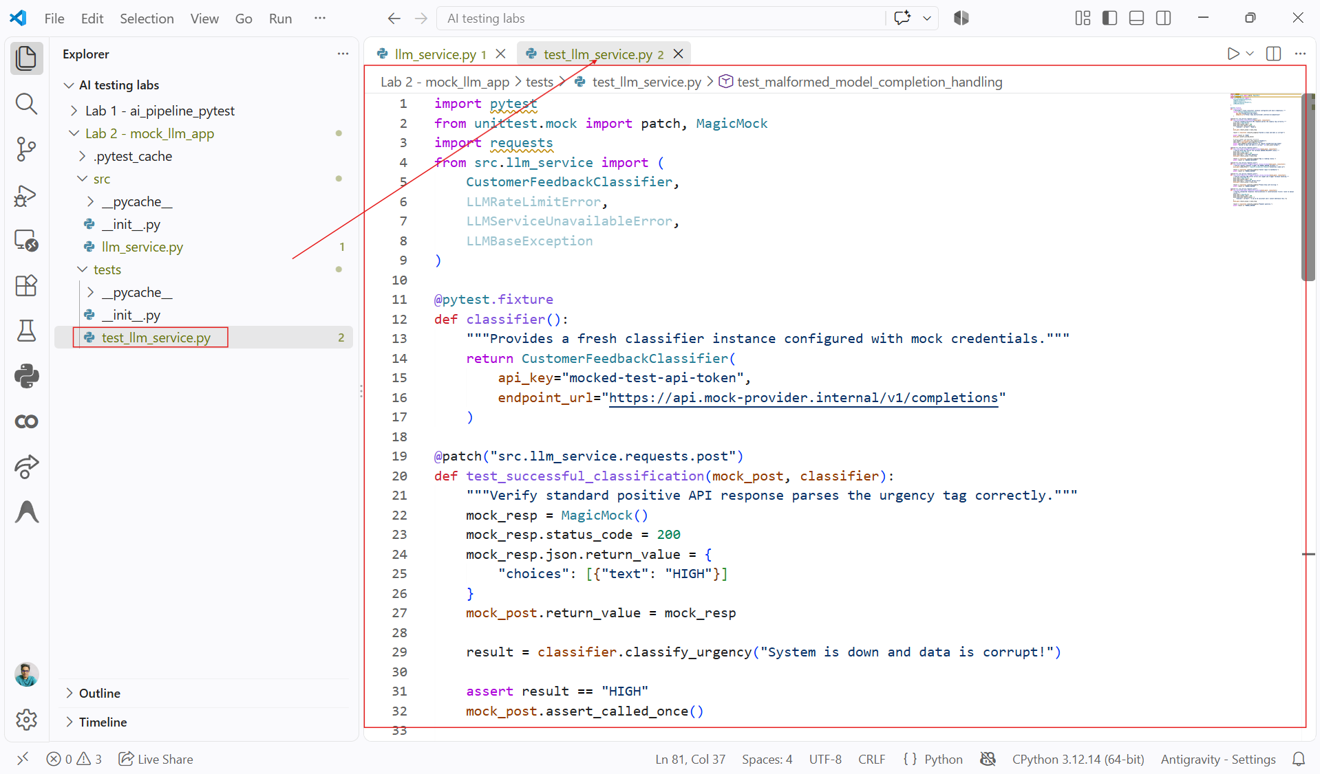

Step 5: Run the Test Suite and Inspect Execution Velocity
Execute PyTest from the root directory using the verbose flag (pytest -v -s). Running this command confirms that all tests pass, that all network calls were intercepted in memory without hitting the internet, and that the entire test suite finishes in fractions of a second.
pytest -v -s tests/test_llm_service.py
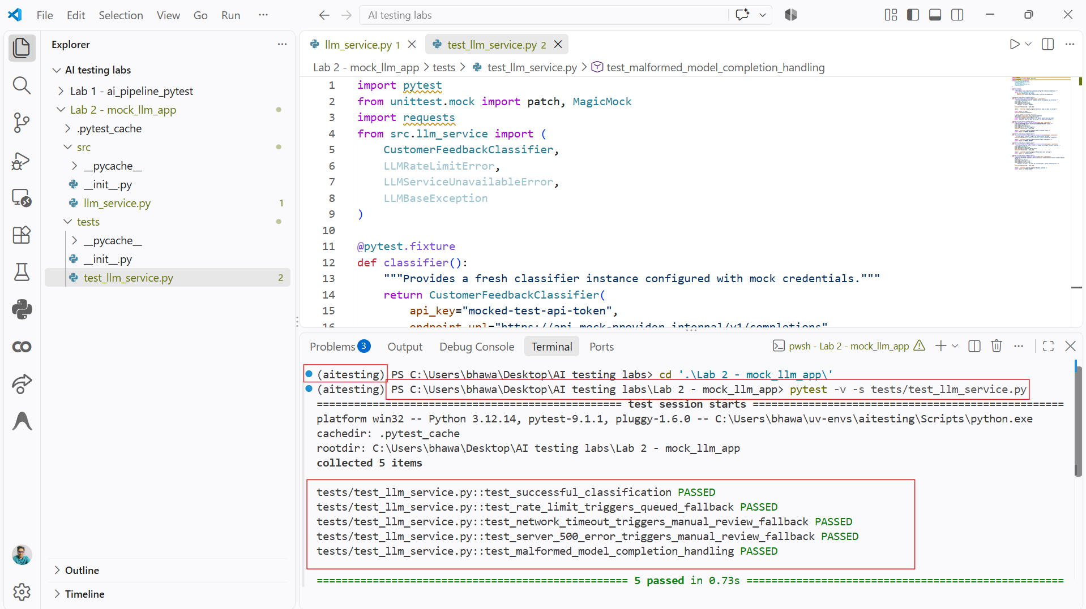
Conclusion:
In this lab, you decoupled an AI-driven classification service from external LLM providers using automated mocking techniques. By intercepting HTTP operations with unittest.mock.patch and MagicMock, you verified request authorization headers, validated request payloads, and tested application resilience against rate limits, server outages, timeouts, and unparseable completions. This mocking approach enables developers to test complex AI applications quickly and deterministically in CI/CD pipelines without incurring API costs or relying on external service availability.

